**MARKETING LETTERS**

**FOR**

**ANNA PLEWA**

**COMPANIES**

Hello and thank you for allowing me to share a wonderful opportunity. As we all know, we live in a time that encourages... demands... enforces... best practices with regard to every phase of corporate existence: building and maintaining a context of positivity and success. When it comes to wellness in the workplace, it is incumbent on companies to inspire, encourage, and support employees and colleagues to "live the best life possible." It is no secret that our world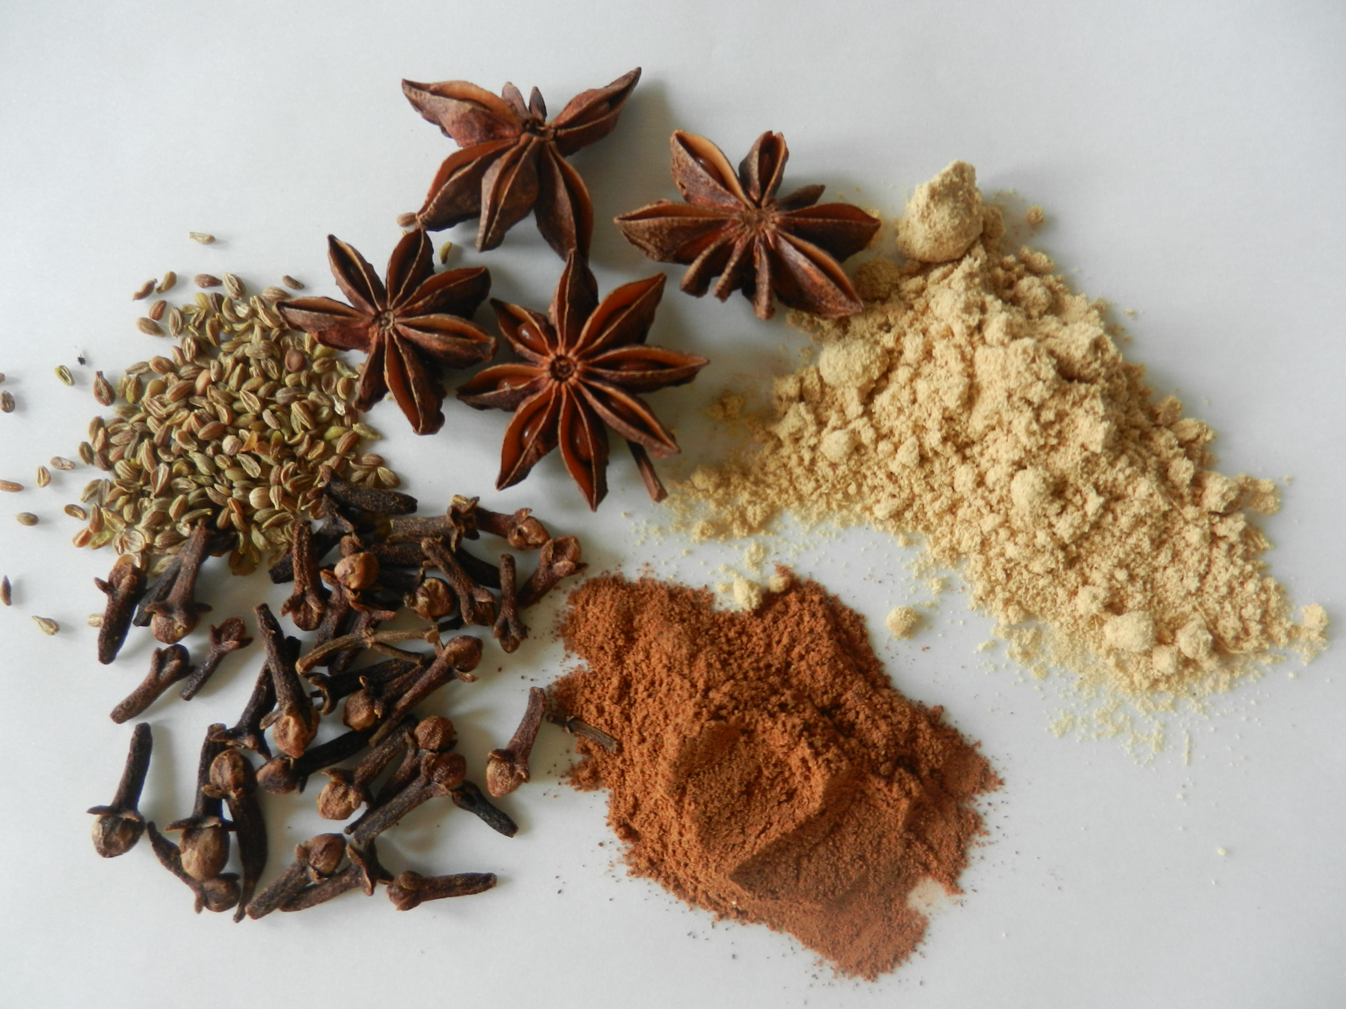 is getting more complicated with each day, and the question of how to find ways to entice and nurture provide its own challenges. I am writing to introduce you to an appealing, simple, and invaluable tool, my book, **Herbs in My Kitchen: A Reference Guide for Every Day Cooking.**

The book is a handy, well organized guide to making delicious, healthy food using colorful herbs and spices while drawing inspiration from major global cuisines. While it is technically not a cookbook, as you will see.... after all, who has the strength to start complicated preparations after an exciting day of work and a challenging commute?... it is a thorough and appealing glossary of spices and herbs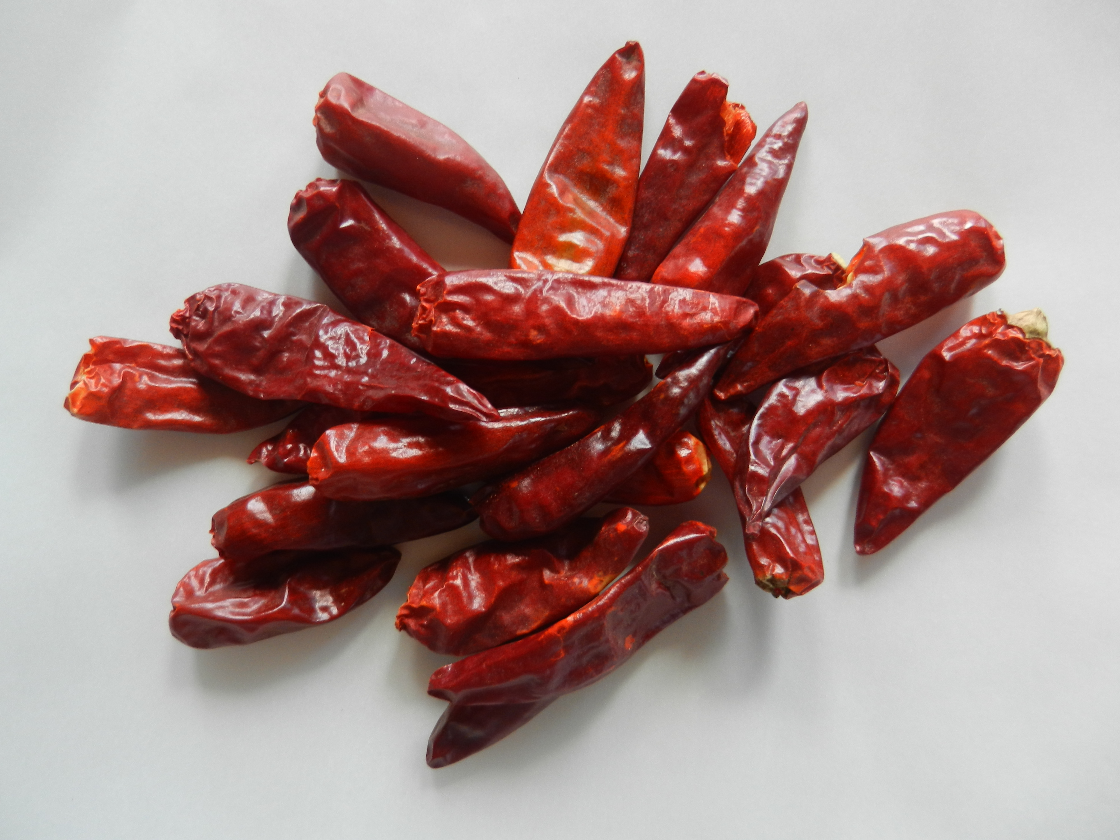 along with suggestions for time saving food preparations.

This book provides a much needed road map to finding and living a nourishing and healthy lifestyle that is essential to support our busy lives. I have spent the past thirty years being my own "case study" and I invite you to share the benefits of my exploration that this book provides.

**Herbs in My Kitchen** creates a wonderful alternative to all of those stressful and ineffective promises we make... and break. I invite you to take a look at the book, and think of how its simple philosophy can have a positive impact on your own wellness and that of those around you. To paraphrase... "living well is the best **gift**..." And whether you choose to place an order for your staff, your colleagues, your friends, or your family, I wish you delicious, tasty, good health! I look forward to hearing from you!

**STORES**

****Hello and thank you for allowing me to share a wonderful opportunity. Since we are living in an exciting time when the rule of the day is "multitasking" and there is the ever present challenge to "engage the consumer," it is my privilege to introduce you to my book, Herbs in My Kitchen: A Reference Guide for Every Day Cooking. While it is no secret that we are all mandated to "live the best life possible," it is no surprise that our world is getting more complicated with each day.... and dieting or eating fast food does not make the most direct route to wellness. The question of how to find ways to entice and nurture the consumer provides its own challenges. I am writing to introduce you to an appealing, simple, and invaluable tool.

The book is a handy, well organized guide to making delicious, healthy food using colorful herbs and spices while drawing inspiration from major global cuisines. While it is technically not a cookbook, as you will see... it is a thorough and appealing glossary of spices and herbs along with suggestions for time saving food preparations.

This book provides a much needed road map to finding and living a nourishing and healthy lifestyle that is essential to support our busy lives. I have spent the past thirty years being my own "case study" and I invite you to share the benefits of my exploration that this book provides.

**Herbs in My Kitchen** creates a wonderful alternative to all of those stressful and ineffective promises we tend to make... and break. I invite you to take a look at the book, and think of how its simple philosophy can have a positive impact on your own wellness and that of those around you. It's time to stop punishing ourselves through broken promises and deprivation... preparing and eating beautiful, delicious food can be accessible to everyone. To paraphrase... "living well is the best **gift**..." And should you choose to place an order to offer in your establishment, I wish you delicious, tasty, good health! I look forward to hearing from you!

**FITNESS CENTERS**

Hello and thank you for allowing me to share a wonderful opportunity. Since the great work you do is dedicated to complete wellness, it is my privilege to introduce you to my book, **Herbs in My Kitchen: A Reference Guide for Every Day Cooking.** While it is no secret that we are all mandated to "live the best life possible," it is no surprise that our world is getting more complicated with each day.... and neither exercise alone nor dieting or eating fast food lead to the most direct route to wellness. The question of how to find ways to entice and nurture the consumer provides its own challenges. I am writing to introduce you to an appealing, simple, and timeless tool.

The book is a handy, well organized guide to making delicious, healthy food using colorful herbs and spices while drawing inspiration from major global cuisines. Although it is technically not a cookbook, as you will see... it is a thorough and appealing glossary of spices and herbs along with suggestions for time saving food preparations. It's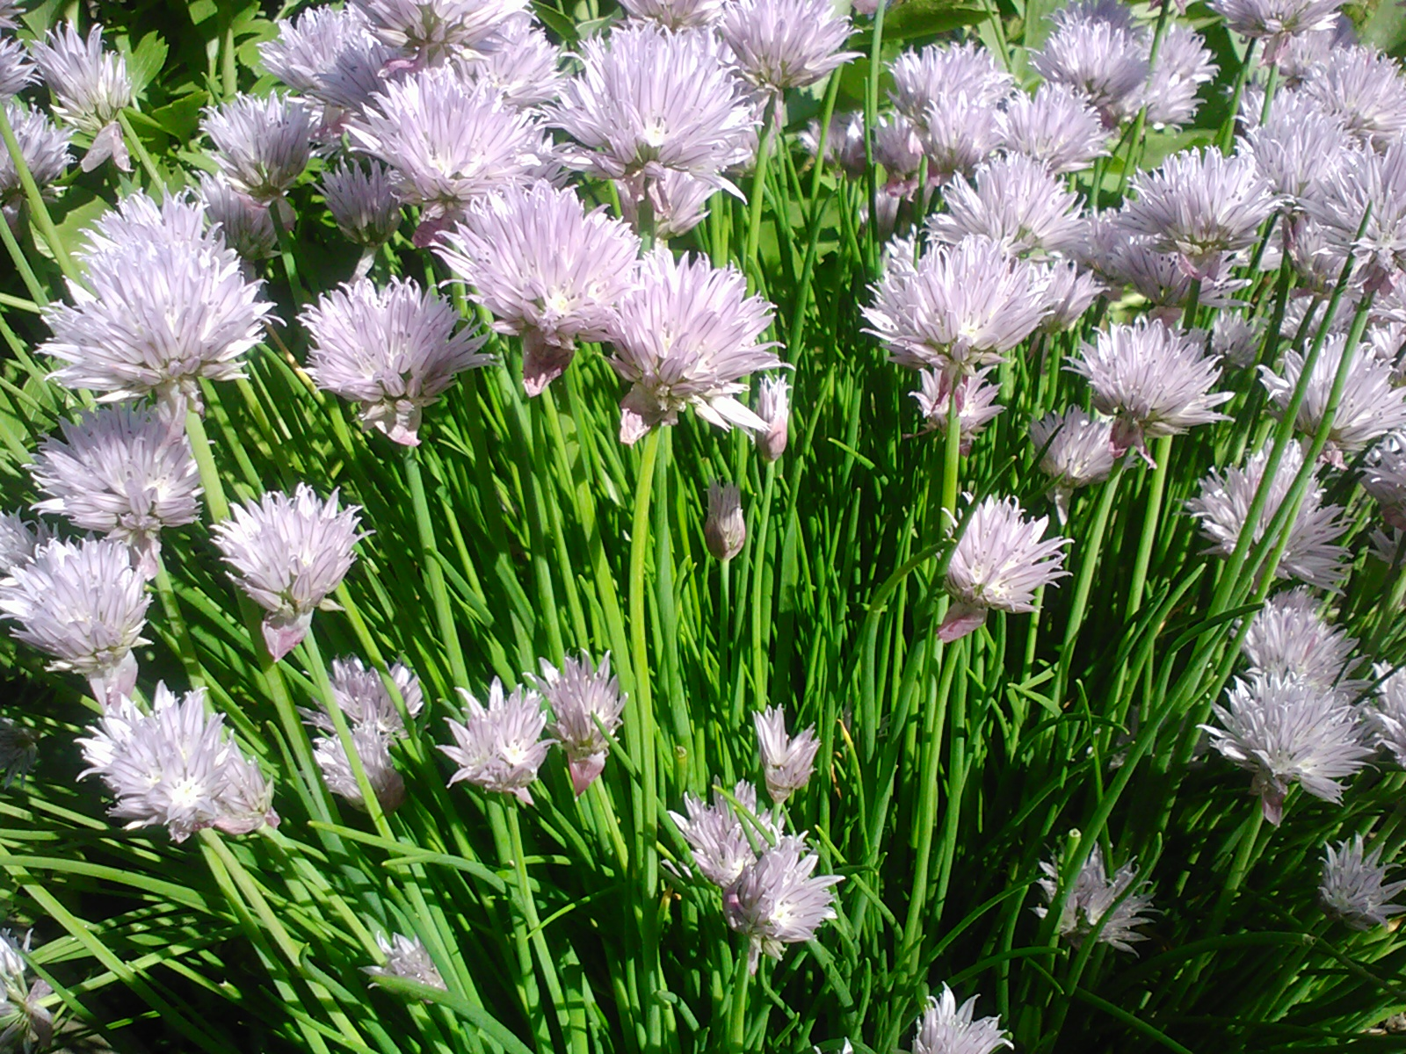 benefits are only limited by the user's imagination... but there are many beautiful pictures and simple tips to ignite the imagination! One satisfied (and inspired) reader was excited to tell me that although she had a reputation for being "domestically disabled," after receiving my book, she learned how to turn on her stove, bake a delicious herb infused salmon, and believe me, no one was happier than I was to see that my message is being heeded!

This book provides a much needed road map to finding and living a nourishing and healthy lifestyle that is essential to support our busy lives. I have spent the past thirty years being my own "case study" and I invite you to share the benefits of my exploration that this book provides.

**Herbs in My Kitchen** creates a wonderful alternative to all of those stressful and ineffective promises we tend to make... and break. I invite you to take a look at the book, and think of how its simple philosophy can have a positive impact on your own wellness and that of those around you. It's time to stop punishing ourselves through broken promises and deprivation... preparing and eating beautiful, delicious food can be accessible to everyone. To paraphrase... "living well is the best **gift**..." And should you choose to place an order to offer in your establishment, I wish you delicious, tasty, good health! I look forward to hearing from you!