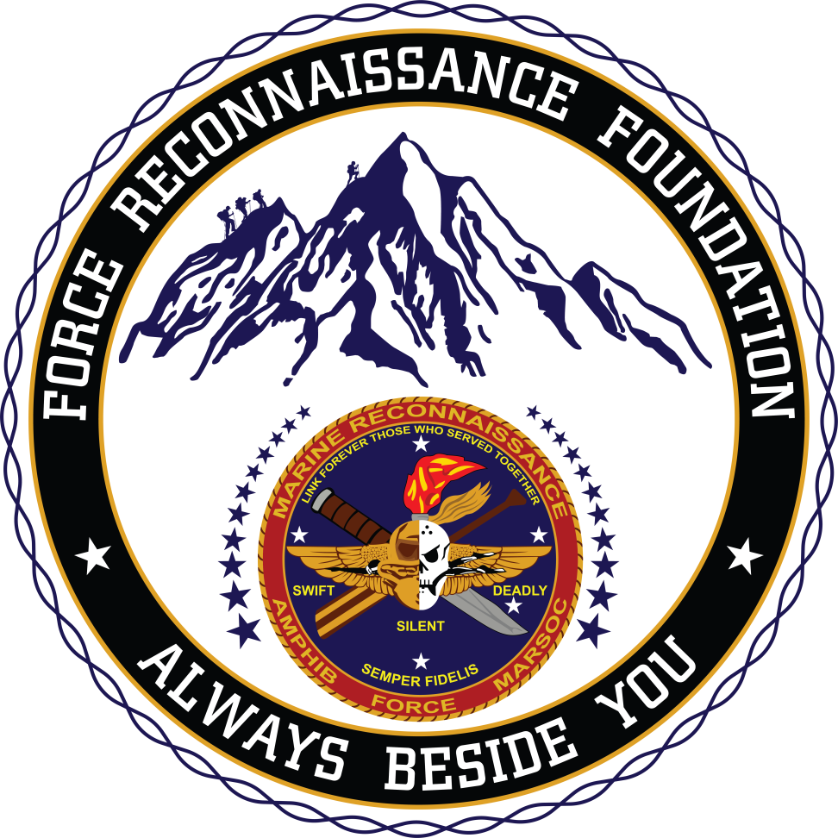

***“All it takes is all you got…”***Several years ago, this phrase emerged within the ranks of a very elite group of United States Marines to describe the physical, mental, and emotional demands required to earn the title ‘Recon Marine’. Their history dates back to WW II when the Corps first established the original Amphibious Reconnaissance Units. Today, they are referred to as “special ops” or “special missions” Marines by virtue of the fact that they are equipped to conduct operations that require very unique skill sets and training only found within the most exclusive military units in the world. In fact, just the Basic Reconnaissance Course is so tough that as many as half of the Marines and Sailors that enrolled have failed to finish the program (54% attrition rate in 2014 according to the Marine Corps Times).

The warriors that do succeed and earn the ‘0321’ MOS (Military Occupational Specialty) go on to serve and lead their elite units in every hostile theater where our Nation is engaged. This story is about one such platoon of Reconnaissance Men who trained together for a deployment to Afghanistan from 2009-2011. They would reject being called “heroes” but their actions tell the real story. Among this group are 25 individual decorations for heroism and valor in a combat zone. Like their predecessors, these modern day American Spartans don’t march away from their battles unscathed; they were awarded 14 Purple Heart Medals.

All but four of the original platoon members have since left the Marine Corps and another three have remained in the Marine Reserves, but the camaraderie, Espirit De Corps, and bond they share with each other continues with every platoon reunion they attend. Together, they’ve traveled to Oregon and Idaho to camp out with their families, gone fishing in California, or just got together to honor a Brother retiring from the Corps. On one very special reunion, they even participated in the grueling Camp Pendleton Recon Challenge Competition. Seeing them come down that mountain carrying their wounded Brother is a site I will never forget!

This year’s reunion is different. Once again, this reunion will challenge **”…all you got”** both physically and mentally because in early June, 1st Platoon, B Company, 1st Reconnaissance Battalion will climb all 14, 410 feet up to the top of Mount Rainier in Washington State. Once again, several wounded members of the platoon will be part of this mission.

It will come as no surprise that such endeavors have a cost associated with them, for gear, supplies and other accommodations. Therefore; over the course of the next few months, the nonprofit Force Reconnaissance Foundation and Mission2Alpha will be supporting several fundraising activities and events to underwrite the “Rainier Recon Challenge” and benefit the Force Reconnaissance Foundation Charities, which are dedicated to the Marine Reconnaissance Community.

We are honored to support this extraordinary event, and grateful to the many patriotic Americans who will offer financial support to this noble mission. I look forward to meeting many of our you at our fundraising activities in the coming months! Semper Fidelis!

Respectfully,

Alan F. Sniadecki

President

Force Reconnaissance Foundation

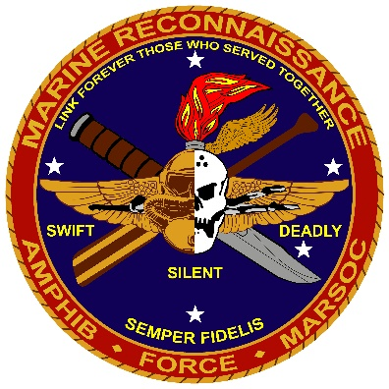

***Always Beside You!***