Discovering the Ancient Lineage of the Polonsky and Paull Family

A Millennium of Genealogy, History, and Heritage

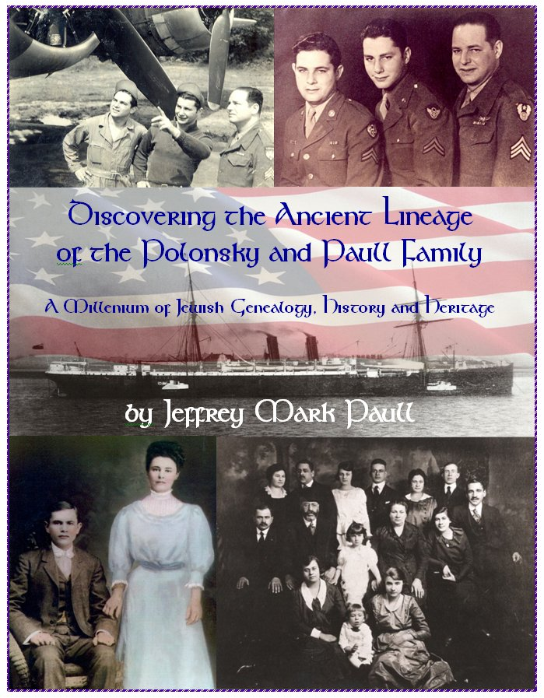
In April of 2008, Dr. Jeffrey Mark Paull set out to create a family tree, for the purpose of familiarizing his son Joshua with his extended family, prior to his Bar Mitzvah. While gathering information for the family tree, Jeff located the Ellis Island immigration and ship records for both his grandfather, Lewis Isadore Paull, and his great-grandfather, Nathan Polonsky.

From these ship passenger manifests, Jeff was able to ascertain where his grandfather and great-grandfather lived in Russia, when they immigrated to America, and which members of the family accompanied them on their voyage.

Armed with just these few basic historic facts, and the family legend of being descendants of an important rabbi, Jeff’s long-smoldering curiosity about his family history and genealogy was ignited, and he embarked on a remarkable journey of discovery, the results of which led to the writing of this book.

It wasn’t long before Jeff made his first major discovery. On his great-grandfather’s gravestone, Jeff discovered a Hebrew inscription that proved that Nathan Polonsky was indeed a descendant of two of the most esteemed and revered Chassidic rabbis in Jewish history -- Rabbi Pinchas of Koretz, and Rabbi Aryeh Leib, better known as the Shpoler Zeide. Both were disciples of the Baal Shem Tov, the founder of modern Chassidic Jewry.
This remarkable finding led Jeff on a search of the surviving Ukrainian archives for his Polonsky ancestors, to obtain original birth, marriage, and census records from the shtetls and towns of the Zvenigorodka uezd (district), including Ekaterinopol, Pereyaslav, and Shpola, and the town of Cherkassy, in a mission to uncover the family’s lost heritage. Jeff also studied numerous texts and articles on the history of the Jews in Europe, and its great rabbinical dynasties, and he corresponded with notable authorities on this subject.

Through a combination of determination, perseverance, and good fortune, Jeff succeeded in discovering the lost heritage of the Polonsky family -- a family whose proud ancestry and lineage or yichus is among one of the most distinguished of the illustrious Jewish families of Eastern Europe, with no fewer than 28 successive generations of rabbis in its lineage, dating back to the world-renown biblical commentator, Rashi.

Through his study of rabbinical lineages and dynasties, Jeff was able to trace the Polonsky family’s descent from, and marriage connections to some of the most prominent and highly-regarded Jewish families of Eastern Europe, including the Friedman, Gelles, Isserles, Halperin, Katzenellenbogen, Shapiro, Treves, Twerski, and Zeida families. These families formed the bedrock of European Ashkenazi Judaism.

Realizing that he now had a story that encompassed 1,000 years of Jewish history to tell, Jeff presents fascinating biographies and teachings of many of the revered rabbis from which the Polonsky family is descended. His book chronicles their lives, and describes the historic events and forces which caused them, over the centuries, to migrate ever-eastward through Europe, from the centers of Jewish learning in 11th Century France, to Germany and Poland, from the 12th through the 17th Century, to the towns and shtetls of Russia in the 18th – 19th Century, and finally, to America, in the 20th Century.

As fascinating as this history is, Jeff considered it just as important to continue the story up through the present, and to tell the story of who the family is today. Over the course of his research, he located every surviving member of the Polonsky family, and conducted personal interviews with as many of them as possible. In the process of locating and contacting family members in the Polonsky family, from which the Paull branch of the family is descended, Jeff bridged a connection between the two branches of the family that had been lost for over forty years.

To supplement the information he obtained from his interviews, Jeff encouraged his family members to submit biographies, letters, newspaper articles, personal remembrances, and photographs of themselves. In order to present as complete and accurate a family history as possible, Jeff also retrieved and analyzed hundreds of records from both the United States and Russia, including birth, death, and marriage certificates, census forms, immigration and naturalization information, and military records.
In addition to compiling and synthesizing this extensive historical record, Jeff made use of 21st century science, by submitting his own biological samples for DNA analysis, in order to shed light on the ancient genealogical derivation of his paternal ancestry.

To most effectively present this massive amount of information and material, Jeff made the decision to publish his book as two separate volumes, both of which are scheduled for publication in 2010. The first volume, “The History and Legacy of the Polonsky and Paull Family in America,” focuses on the family’s history since immigrating to America. It tells the story of the Polonsky family, beginning with the family patriarch, Nathan Polonsky, and covering all of his known descendants, numbering over 200 family members within each of the eight main branches of the Polonsky family. This part of the Polonsky family history, spanning a total of six generations in America, contains detailed biographical information and photographs for each family member.

Jeff’s deep love and admiration for his family is evident in the way he honors the many notable personal accomplishments and achievements of each family member, the care with which he highlights the defining moments in their lives, and the manner in which he chronicles their wartime experiences, and service to their country.

The second volume, “Discovering the Ancient Lineage of the Polonsky and Paull Family -- A Millennium of Jewish Genealogy, History, and Heritage,” focuses on the history and ancestry of the Polonsky family. It traces Nathan Polonsky’s descent from Rabbi Pinchas of Koretz, and through this lineage, chronicles his descent from Rashi in 11th Century France. It also traces Nathan Polonsky’s descent from the Shpoler Zeide. Accompanying this genealogy is the identification and description of each of the many illustrious rabbis in this ancestral chain, as well as the times in which they lived. Comprehensive family trees are also presented which elucidate the many family inter-connections between the Polonsky family, and other prominent and distinguished Jewish families of Eastern Europe.

Illustrated and supplemented by numerous tables, maps, family trees and lineages, rabbinical histories and appointment letters, biographies, information on ancestral towns, DNA ancestry information, Russian vital records with translations, and hundreds of family photographs, many of them meticulously restored, this two-part magnum opus is breathtaking in its scope, and stands as one of the most comprehensive family histories of its kind.

A fascinating and remarkable story of a 1,000-year journey through Jewish history, to discover his Polonsky family’s lost heritage, Dr. Jeffrey Paull has succeeded in creating a truly magnificent living legacy -- a gift that is sure to be treasured by his family and their descendants, as well as Jewish historians and genealogists, for many generations to come.

