**FOR INTERNAL USE ONLY. DO NOT DISTRIBUTE.**

**Policy Platform**

June 15, 2019

Shaune Freeland

for Punta Gorda City Council, District 3

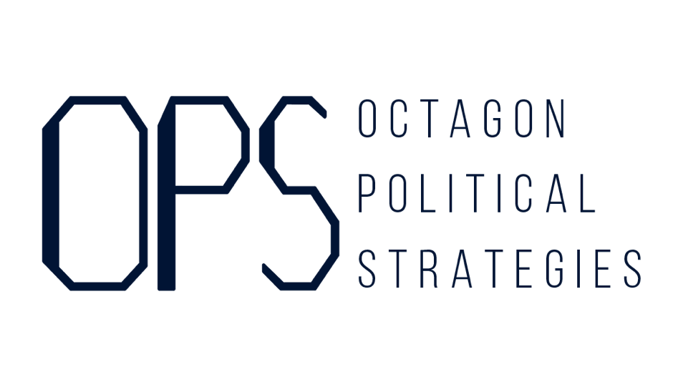

**Development and Growth**

Our City is at a pivotal moment in its story. We need a City Council member who will promote conscious, sustainable, and beneficial development that preserves our community while improving it for residents of all ages and means. To accomplish this goal, Shaune Freeland will:

* Protect, preserve, and enhance property values and our way of life in Punta Gorda
* Promote policies that emphasize walkability in Downtown and beyond
* Defend historical preservation of landmarks and neighborhood architecture
* Prioritize construction of Workforce Housing within city limits to accommodate our groqing community
* Champion small business and work to attract more local entrepreneurs to the area
* Pursue a community-focused project with greenspace, retail, and space for the arts to make City Marketplace the centerpiece of a vibrant Downtown.
* Remove unnecessary roadblocks for those seeking to invest in Punta Gorda, such as increasing allowable building heights without need for a variance.

**Pickleball**

Pickleball is an incredible addition to the vibrant lifestyle that Punta Gorda offers and will provide many opportunities for our city in the future. We cannot let Pickleball interfere with residents’ quality of life by disturbing them in their homes. The City should take full advantage of its investment by moving pickleball activities that currently take place at Gilchrest Park to the PicklePlex at Florida Southwestern University’s campus as soon as possible.

**Strengthening Our Community**

Punta Gorda should not only welcome all who wish to become a part of our unique and warm community but help them in their journey regardless of age, economic status, or race. City Council should actively encourage policies that further improve Punta Gorda’s reputation as an opening and welcoming community.

**Protecting our Environment**

Punta Gorda’s natural beauty and resources are important treasures and contribute to our community’s amazing quality of life. We must pursue every avenue possible to protect our environment from human damage and preserve it for the future. City Council should ban commercial use of all plastic straws and carrier bags within a quarter-mile of the coastline.

**City Budget**

The current City Council has failed Punta Gorda residents by passing the buck on city expenditures time and time again. Financial reserves are vital to rapid emergency response. We should not unnecessarily deplete our reserves to cover budget shortages. Shaune Freeland will fight for a balanced annual budget that protects taxpayer dollars from misuse.

**Public Safety**

Our City is blessed with a dedicated group of first responders. As our population grows and land area expands, we need to maintain excellence among police and fire services. City Council should approve pay raises for our first responders that keep Punta Gorda in competition with the rest of Southwest Florida as an outstanding place to serve.

Shuane Freeland supports mandatory use of body cameras for all Punta Gorda Police Department officers to keep our law enforcement personnel accountable to the public that they serve.

**Sunseeker**

Punta Gorda residents and small businesses have benefited greatly from our airport’s partnership with Allegiant Airlines. Our community will continue to thrive as this relationship grows with the addition of Sunseeker Resort. The Punta Gorda City Council should strengthen our ties with Sunseeker and Allegiant and promote further collaboration within city limits through business partnerships, zoning, and service expansion.

**Transparency and Accessibility**

Our City Council works for the people, so it should be open and accessible to all citizens wishing to participate. City Council should alternate meeting times between morning and evening to provide greater opportunity for working citizens and parents to make their voices heard.