**Dr. Jaynandika, Senior Data Scientist**

**Title of the talk: The Pioneering role of AI to predict market cap in profitable trading system**

**Abstract :** Artificial Intelligence (AI) is a powerful cutting edge techniques from world-class data science which is playing an essential roles in all business. Currently, Artificial Intelligence is pioneering in saving time and money by automating routine processes and tasks. For example, different organizations and people have adopted AI technology to increase productivity and operational efficiencies to make significant and efficient business decisions based on outputs from cognitive technologies. AI helps to avoid mistakes and 'human error' which improve the performance in current business. AI is changing our lives in different ways for each year. For example, business people are using it to analyze and forecast for their business. We want to look at some of the roles it’s playing in workplace, from the entryway to your cubicle in the back, especially in the banking sector. This intellectual discussion will explain about how market capitalization influence by the power of social media in financial industries using artificial intelligence.

Keywords: *Artificial Intelligence, machine learning, deep learning, stock price, market share, social media*

*including*

*joke*

*literary story*

*raise people interest*

*expertise in a particular field*

*raise enthusiasm among prospeddtive attendees*

*quotes*

*some research metrics*

*audiances – students, lecturers, professors, chair persons and guest.*

*speech should be intellectual technical talk not in general*

**ARTIFICIAL INTELLIGENCE (AI)**

A popular concept featured in fiction films such as “The Terminator” and “AI: Artificial Intelligence”, the idea of artificial intelligence is inching closer to a reality that is already being integrated into our daily lives through the use of technologies like virtual assistants (Siri, for example), smart cars and homes, and automated customer service. Companies and individuals are racing to keep ahead of a world in which predictive algorithms, and neural networks are becoming the future of technology, and these ideas are advancing at accelerated rates. Be sure your company stays at the forefront of artificial intelligence technology by bringing in an artificial intelligence expert, futurist, or technologist to your next conference or event.

[*https://www.youtube.com/watch?v=ftMq5ps503w*](https://www.youtube.com/watch?v=ftMq5ps503w)

*1940s – used arima*

*1980s – spread sheet*

*now – neural network*

*just spent 3 years writing lst code in C++*

*GOOGLE released Tensorflow train on massive data*

*normalize each data point*

*ni = (pi / p0) – 1 – to divide initial price with this value – normalize value to effect percentage changes*

*pi = p0(ni + 1)*

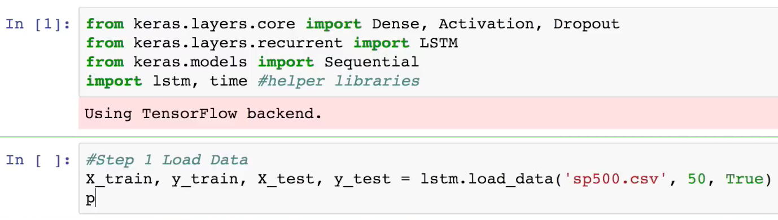

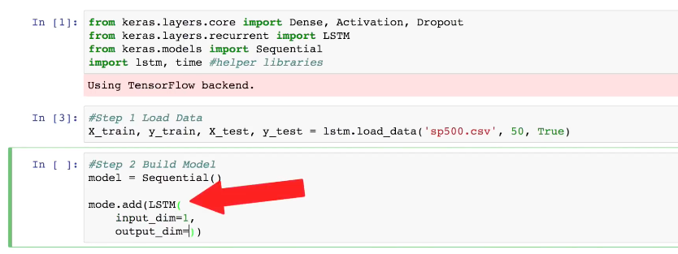

*memory matters*

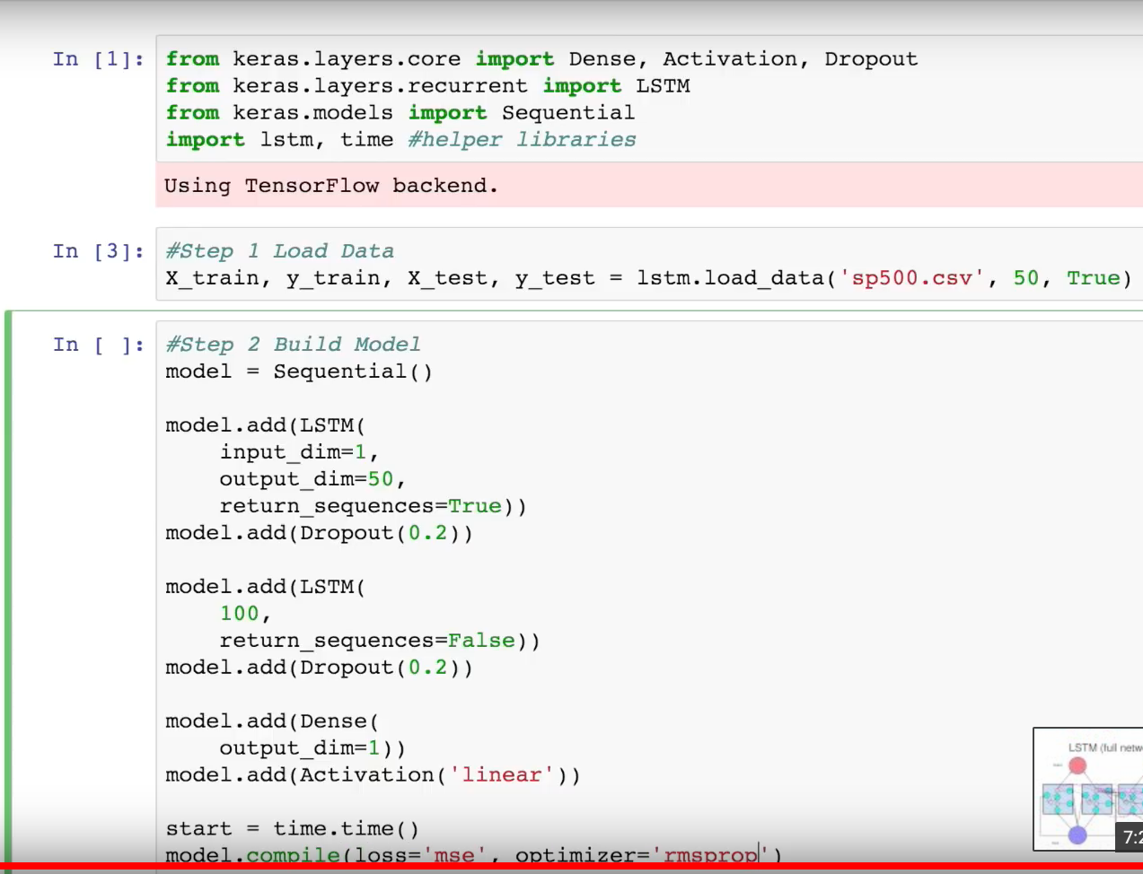

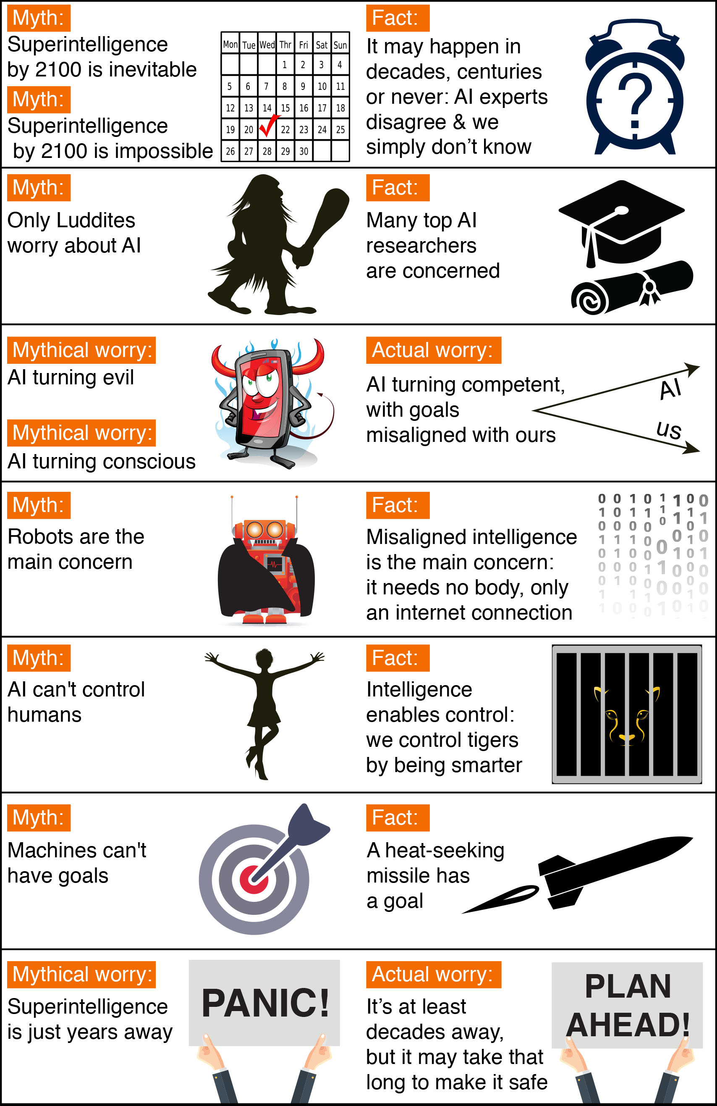

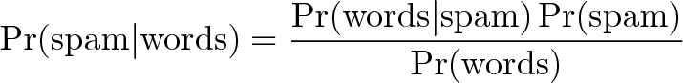

<https://chrisalbon.com/#python>

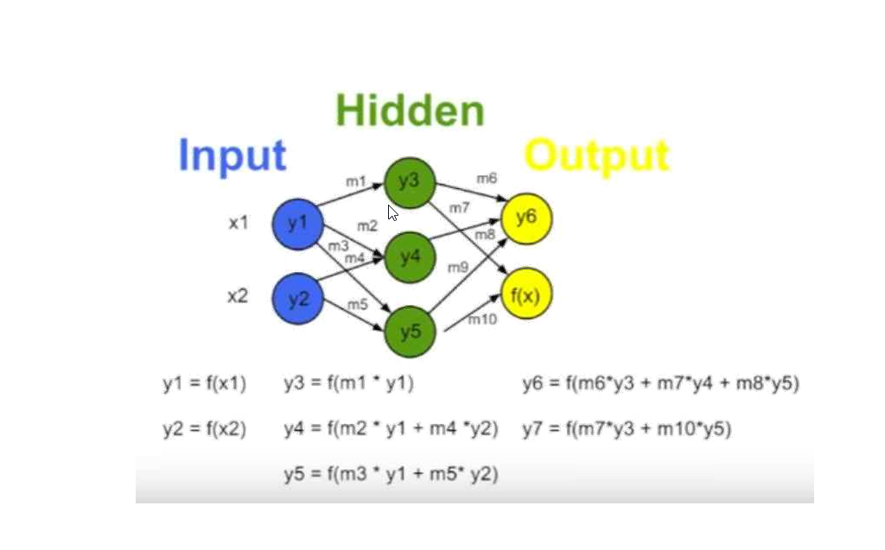

*since I will be very farway from prediction.*

*back propogation:*

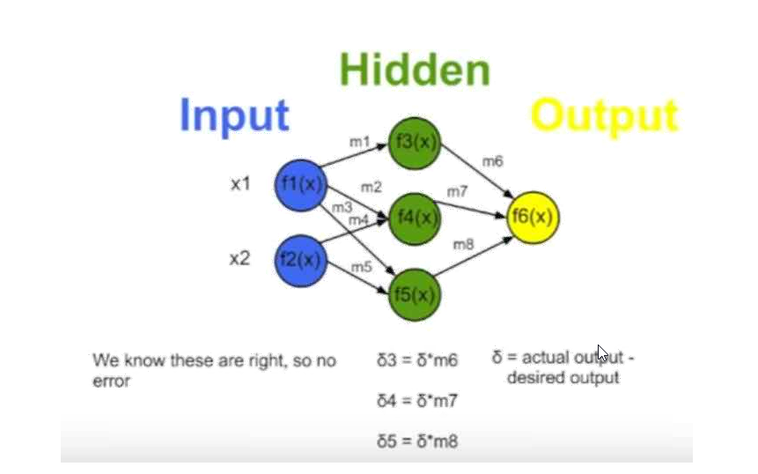

*delta give me new strenth*

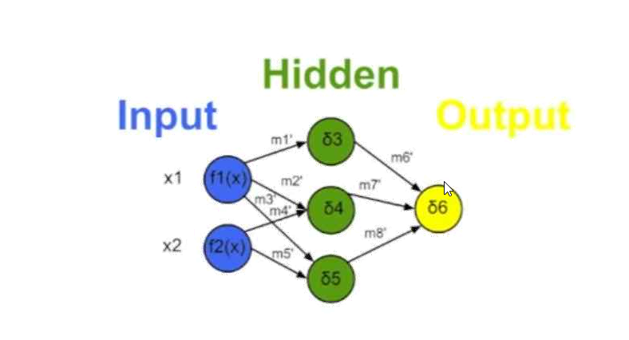

*stop at point where the error is minimum*

*joke*

*literary story*

*raise people interest*

*expertise in a particular field*

*raise enthusiasm among prospeddtive attendees*

Objectives -

      i.         Understanding the meaning of Artificial Intelligence and Machine Learning and what is data science? what are the steps involved in data science?

    ii.         Why Artificial Intelligence and Machine Learning are popular

   iii.         How Artificial Intelligence impact financial Industries

   iv.         How social media impact market capitalization using data science

  v.   How LDA - Topic model works?

vi. How deep learning LSTM (Long Short term memory works), what is the concept behind in

vii: what is the conclusion part.

*how to win the the future?*

*I am going to explain about 5 points*

*we are all connected globally. we need to have more and more ability to learn which is human nature.*

*Whitney Johnson, if you are willing to change who you are, and growing where you are before. it is ok to say, I don’t know, it is really important to say i don’t know.*

*there are two mind set, growth mind set and fix mind set, we are need to be in growth mind set.*

*leadership: increasing and powering our team to make success, leadering and finding for the future. what is your contribution to the world.*

*M. Williamson stated that “ your playing small does not server the world. “ you are here to play big.*

**peaker 0:**

So thank you very much for coming David it's good to have you here.

**Speaker 1:**

Good as my pleasure Michael glad to be with you.

**Speaker 0:**

How real is artificial intelligence.

**Speaker 1:**

The question of how real is artificial intelligence is a complex one on I would say if if we define artificial intelligence is the ability of a machine on its own to understand large volumes of data to reason that data with a purpose to it to predict the future and then tell you continue to learn and get better that is happening today in certain fields.

**Speaker 0:**

How far in the continuum is IBM Watson in operability artificial intelligence.

**Speaker 1:**

Yes so so first of all once once it's actually intelligent it will no longer be artificial so we're moving to the point that these systems increasingly understand enormous volumes of data.

**Speaker 0:**

Thank you for that.

**Speaker 1:**

First.

**Speaker 1:**

IBM again a company long admired.

**Speaker 1:**

Has been successful in reinventing itself for decades across multiple industries in a I now that is the central focus of the platform going forward how did you and your team think about the development of a I what was the right platform how did you come up with the guidelines that you're going to now use and push forward with your business customers what are some of those guiding principles.

**Speaker 0:**

Yes so and I appreciate that introduction and at a hundred and five years old we have been through a number of different transformations and if you think about each one there's something that provides the foundation and the basis of it and this goes back many years ago and there's actually a reason to why a I would actually call it cognitive in the basis is that we would be so overwhelmed with information that it would be impossible for any of us actually internalize it use it to when it's full value could be.

*Market cap prediction using AI in finance*

*Actually predicting stock price is a game, how we use AI for this successful trade for buys and sells. who is working on behind us*

*When is the good time to buy and when is the good time to sell the stocks*

*In this demo, we are going to see how deep learning helps*

*AI helps immensly in fintech, finace industries, who is doing this*

*finance industries started first in wall street from 1970s. how fast stock moves, then can predict fast. there are so many data points out there in web, they don’t want to know us, how they are calculating and predicting, they are trading secret. tweets, red in post, geo science, financial meta data, stock prices, little metrics how use time series analysis, it is not mulitvariate problem, different ways to classify this problem, neural network, svm, deep learning, citibank double – there are so much data, you have an opportunity to build model and find some soultion, start do it now.*

*Reducing costs is not abot labor arbitrage and offshore hiring. its about automation now.*

*90% of the worlds data collected in past 2 yesrs. Never been a better time for this.*

*Resource-intensive, repeititive tasks, such as data entry and transactions processing, are well suited to automation and AI.*

*CFOs of big companies and startup enterpreneurs need to be looking for ways to use AI to improve FINTECH(Planning, budgeting and forecasting, financial reporting, operational accounting, allocations and adjustments, reconcilations, intercompany transactions)*

*Where do you expect AI/Machine learning technology to be introuduced in your organization in the next three years? answer is risk assesment.*

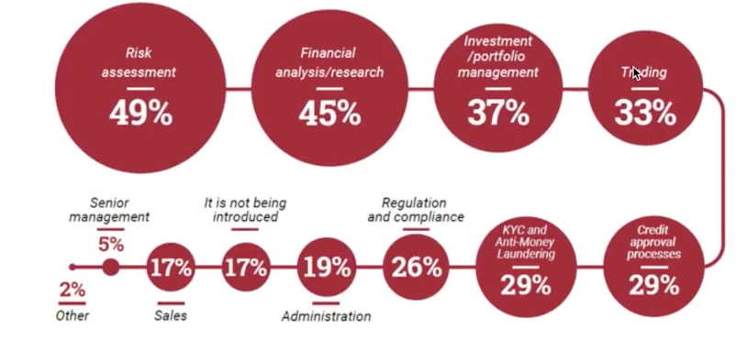

*The market for AI in financial services is expected to grow from 1.3 billion in 2017 to 7.4 billion in 2022, at a CAGR of 40.4%, according to Research and Markets.*

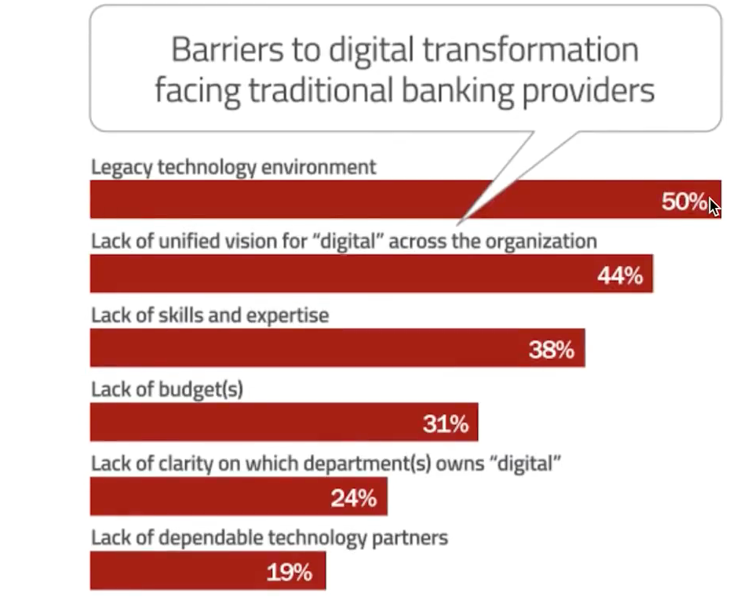

*There are paing points, they want AI, you will build brand, and pick one specialized area and expertise on it.*

*there are 100s of startup companies bringing Artificial Intelligence to Fintech.*

*THE AI FINTECH MARKET MAP*

1. *Credite scoring / Direct Lending*

*Use AI for robust credit scoring and lending applications*

1. *Assitants/Personal Finance*

*AI chat bot and mobile app assitant applications to monitor personal finance*

1. *Regulatory, compliance & Fraud Detection*

*Use AI to detect fraudlent and abnormal finance behaviour, and/or use AI to improve general regulatory compliance matters and workflows.*

1. *Quantitative & Asset Management*

*Employ AI algorithemic trading and investment strategies or tools*

1. *General purpose / Predicitive Analytics*

*Use AI for general purpose semantic and natural language applications as well as broadly applied predictive analytics.*

1. *Insurance*

*USE AI to quote and insure*

1. *Market Research / Sentiment Analysis*

*USE AI to efficiently research and measure sentiment*

1. *Debt collection*

*Use AI to improve creditor collection of outstanding debt through personalized and automated communication*

1. *Business Finance & Expense reporting*

*Use AI to improve basic business accounting including expense reporting.*

*decrease the rate of false positive, human behind misclassify this, it is billion involved, it is real problem, they are saving company for fraud detecction*

*AI can learn from even what direction your mouse move and how fast you select purchasing, you can’t think about how much data points AI is collecting*

*20% switch their bank after experiencing fraud.*

*SIFT SCIENCE:*

*Sift Science collects data from more than 6000 websites, this enables it to track and analyze data across multiple channels and devices*

*AI helps for reducing process time*

*ParaScript – read the reciepts*

*its powered by aritficial intelligence and machine learning, which helps automatically classify, locate and extract all key data from your reciepts captured from all devices.*

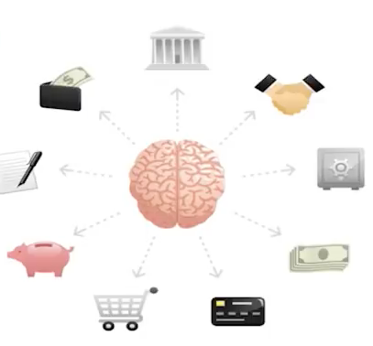

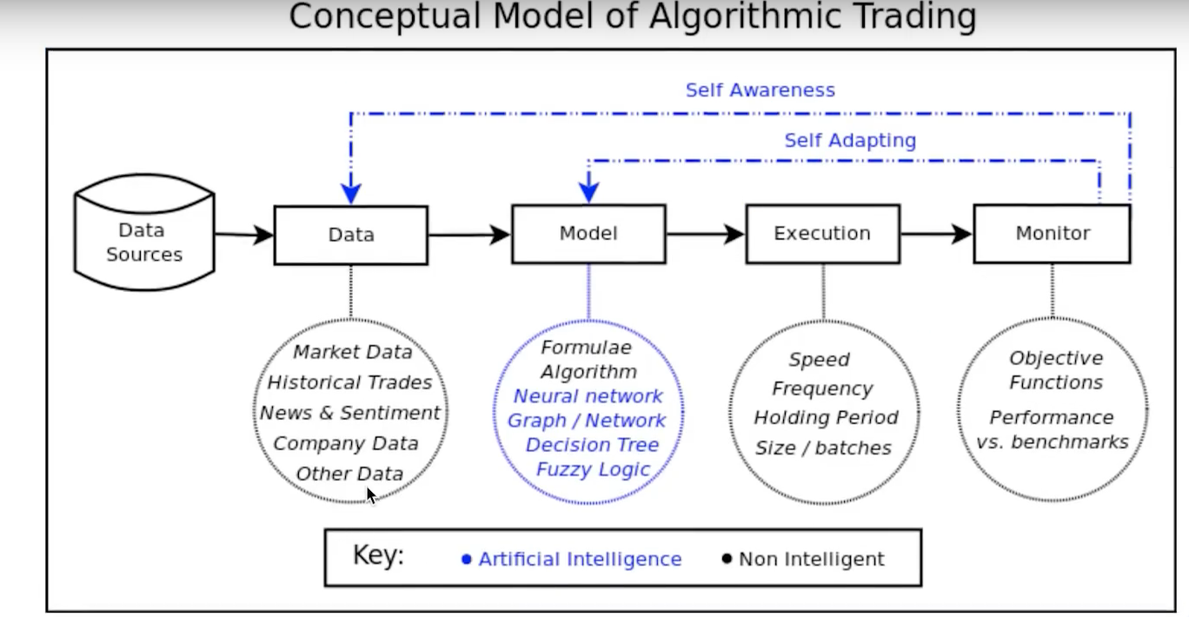

*Algorithmic trading involves the use of complex AI systems to make extremely fast trading decisions (originated in 70s)*

*Algorithmic systems often making thousands or millions of trades in a day, hence the term “high-frequency trading” (HFT), which is considered to be a subset of algorithmic trading.*

*Most hedge funds and financial instittuions do not openly disclose their AI approaches to trading (for good reason), but machine learning and deep learning are playing a increasingly important role in calibrating trading decisions in real time.*

*The stock market moves in response to myriad human-related factors that have nothing to do with ticker symbols, and the hope is that machine learning will be able to replicate and enhance human “intuition” of financial activity by discovering new trends and telling singals.*

*some popular hedge funds using AI include – Two Sigma, LLS, PDT Partners, DE Shaw, Man AHL, Citadel, Vatic Labs, Point72, Cubist etc.*

*Sentiment technologies, an AI company based in San Franciso that also runs a hedge fund, has developed an algorithm that ingests millions of data points to find trading patterns and forecast trends, which enable it to make successful stock trading decisions.*

*Sentiment runs trillions of simulated trading scenarios created from the vast amouns of public adta available online.*

*Squeeze 1,800 days of trading into a few minutes.*

*Successful trading strategies, which it calls “genes”, are then tested in live trading, where they evolve autonomously as they gain experience.*

*Numeri – what is Numeri?*

*A new kind of hedge fund built by a network of data scientists. high frequency trading bot. 18000 trading in few minutes*

*AI - credit Lending.*

*Portfolio Management – need AI – ROBO ADvisor*

*If we cannot afford the money to hire finance advisor*

*The term “robo-advisor” was essentially unheard-of just fiive hyears ago, but it is now commonplace in the financial landscape.*

*These are alogorithms built to calibrate a financial portfolio to the goals and risk tolerance of the user.*

*Users enter their goals (for examples, retiring at age 65 with 250,000 in savings), age, income, and current financial assets.*

*The robo-advisor then spreads investments across asset classes and financial instruments in order to reach the user’s goals.*

*The system then calibrates to changes in the user’s goals and to real-time changes in the market, aiming always to find the best fit for the user’s original goals.*

*Robo-advisors have gained significant traction with millennial consumers who don’t need a physical advisor to feel comfortable investing.*

*Similarly, AI-enabled personal finance intelligence applications are helping consumers manage their finaces, analyze spending, automate tax form filing, and make financial recommendations with a business model not predicated to generating fee from investments.*

*Theory*

*web – scrapped*

*Tweets about a comany (good/bad)*

*Reddit Posts (good/bad)*

*News headlines about a company (good/bad)*

*Past prices*

*All sorts of social media, blog posts*

*All sorts of financial metadata (dividends, finanacial reports, etc)*

*we have pandas, scikit learn, TensorFlow, Keras, deeplearning*

*Regression Problem vs Classification Problem? answer is both ways*

*simplest – single variable regression problem – y= mx + c*

*predict future*

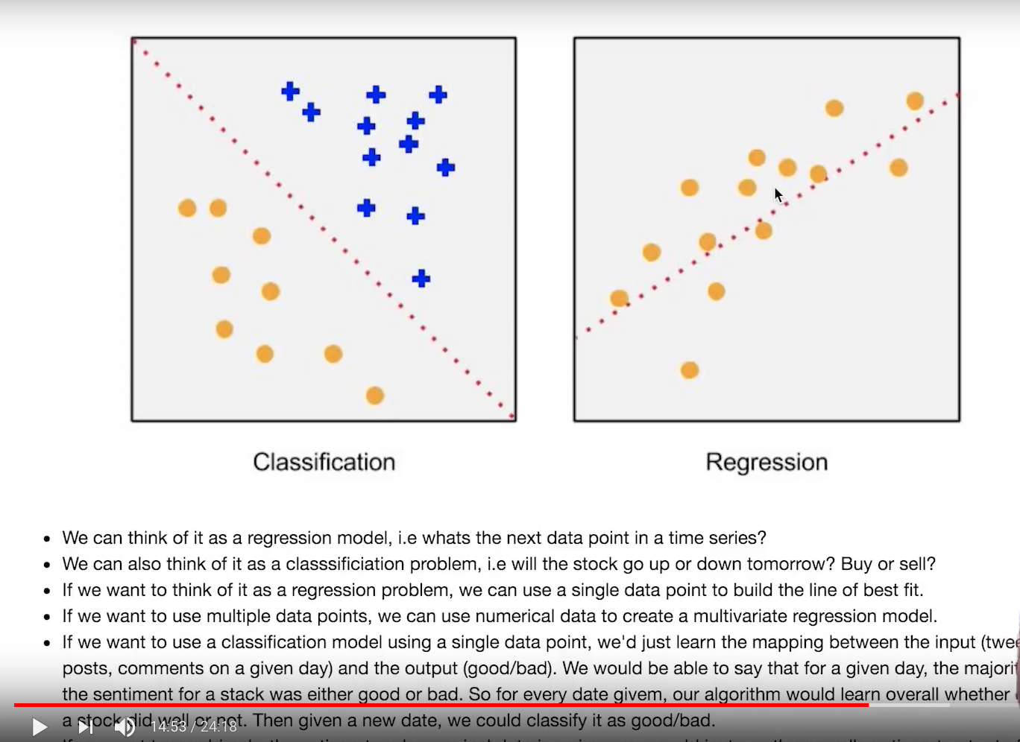

*compile*

*pretrained training dataset, neural network*

*NLTK, TextBlob, regression and classification, numerical data and text data*

*majority all good or bad*

*0 or 1 and add into single rows in numerical data and do regression problem as a linear*

*price and date, it is very easy to do*

*another model, we can use SVM*

*NEURAL NETWORK is very popular*

*take a input and multiply by weight metrics*

*LSTM – sequences for in future. giving lot of progress in this field. same scikit learn load the data and TensorFlow and Keras for analyzing the data*

*Reinforcement learning*

*A forecast predicts future events.*

*A reinforcement learning agent optimizes future outcomes*

*learning from trial and error, reinforcement learning and reinforcement optimize the different outcomes. what to do and not to do.*

*Sairen – OpenAI Gym Reinforcement Learning Environment for the Stock market*

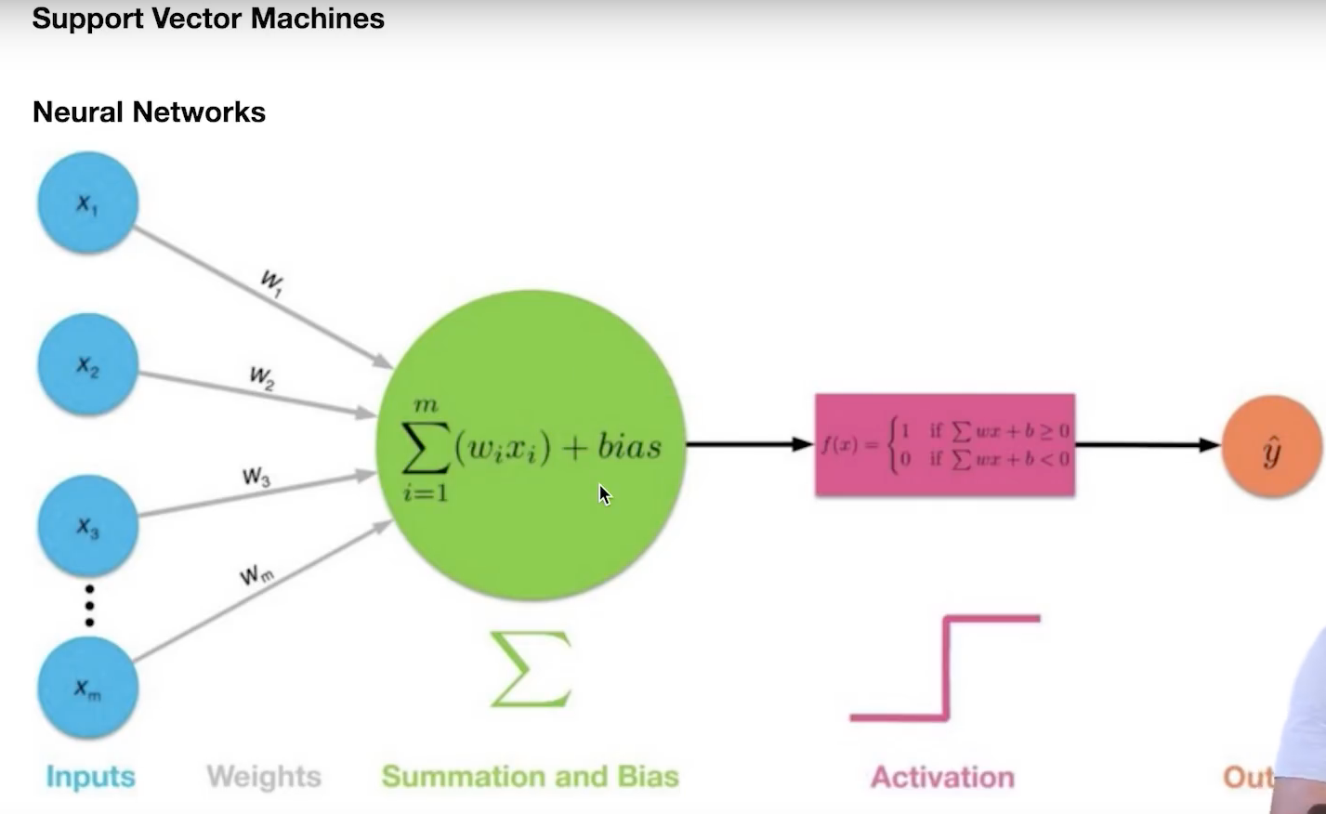

*real live financial market*

*quandi*

*simple linear regression*

*input is date*

*output is stock*

*LSTM*

*what, why, how, when, where.*