Mercer Island, Washington – Sakineh Aziza Nowbar of Mercer Island passed away on Wednesday November 10th, 2021.
Aziza was hit by a car on Monday November 1st and chose that further interventions were not in line with her beliefs and desires. She passed with her children at her side at Harborview Medical Center on Wednesday November 10 at 6:05 am.
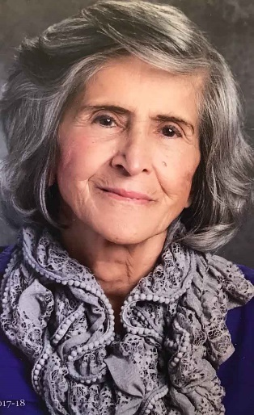
She was born in Sari, Iran to Seyed Ebrahim Nowbar and Maryam Golpaigani.
She is survived by her Daughter Negin Nowbar-Nekahi, Son A. Michael Nowbar Nekahi, Daughter-in-law Lisa San Diego, Granddaughter Lorraine Soraya Blattman, Grandson Reece Vali Nekahi, sister Robab Naimi and brother Seyed Sadroddin Nowbar.
She was pre-deceased by her mother, father, and brothers Seyed Reza Nowbar, Seyed Morteza Nowbar, Seyed Mehdi Nowbar, and Seyed Taghi Nowbar.
Aziza graduated from the University of Tehran with a degree in Geography and Social Sciences. She became a teacher which she cherished until the day she died. She refused to retire and kept going back year after year to serve as a substitute because she loved being with children and teaching so much.
Aziza was a force to be reckoned with. When she set her mind to something it would become a reality maybe not today but eventually you can be sure she would not forget.
She was a proud woman who was independently wealthy in Iran and successful. When she immigrated to the United States with her two children aged 6 and 4 at the time, she had nothing but high hopes and dreams for her family. Her intention had been to visit her then husband, who was attending university, and allow her children to go to American schools and learn English. After a short reunion, her husband would later abandon her and left her barely speaking any English and minimal resources. Iran was falling apart and family advised her not to return in order to provide the best opportunities to her children.
She did not return, she left behind all that she had to provide her children with the American Dream while working minimum wage jobs to make ends meet. She never looked back but instead set her mind to raising her children as best she could. She endured through determination and hard work. She would simply not fail herself or her children. She eventually learned enough English to return to the career she loved. Although her degrees were not accepted in the US she was able to become a Teacher’s aid in the classroom, a career she valued until her dying day. Despite Covid and her ripe age of 82 she refused to retire fully. Aziza gave up driving years ago but continued to use Uber and Lyft to go to work every day. To her it was staying active, engaging her mind, and feeling needed and wanted that gave her the most joy.
She became a grandmother first in 2010 to her granddaughter and then again in 2011 to her grandson. Nothing gave her more pride and joy than these two children. The same fervent love and devotion in which she raised her children would now set its sights on these two grandchildren. She was that grandma who came over every morning to give her infant granddaughter full body massage before going to work to ensure that she was relaxed and her body was flexible and healthy. She would get on the ground and roll around with them both, loved to cook organic homemade meals for them, and she invented games to no end to pass hours of time filled with laughter and smiles. She was also the adventurous grandma who would ride roller coasters and go tubing with them on hot summer days on Lake Washington. She also had a sweet tooth so the three of them would enjoy desserts and ice cream together on regular occasions. She was hands down the greatest grandmother one could ask for and not long after the children started talking, she quickly earned the name “Mazi” which became short for grandma Aziza.
Aziza believed in empowering women. Something that was passed down to her from her own widowed grandmother who refused to marry in turn of the century Iran, when this was unheard of, but instead started a seamstress business in her home to support her family. This was encouraged by Aziza’s father who despite the norms educated his daughters and believed their worth was just as great as his sons and refused to allow her value to be diminished. With those role models she continued to encourage this in friends and family members believing that the path to empowerment was through education and financial independence. A favorite quote from her was “your hands should always go into your own pocket, not your husbands”.
This is the vein in which she raised her children enabling her daughter to pursue an MD PhD and her son to become a successful businessman, both receiving degrees from University of Washington. In short, she was a woman of great integrity, strength, and determination, all of which was hidden inside a petite physique. She loved fiercely and to the point that it would blind you. Aziza wanted the world for you even when you didn’t know you wanted it.
She had unwavering faith in god and spirituality. She was proud and strong and left people with a distinct impression of who she was. She is loved and adored beyond words.
Aziza loved to garden, cook, walk, travel, watch YouTube videos on her iPad, and spend time with her family. She was an avid gardener and was known for her countless rose bushes and jasmine plants.
Services will be arranged for Spring 2022 in order to respect Covid precautions and accommodate a large number of people. We will announce the event closer to the time.
To make a donation in her honor, visit https://give.uwmedicine.org/give/ please select Harborview Medical Center Caring Fund.

