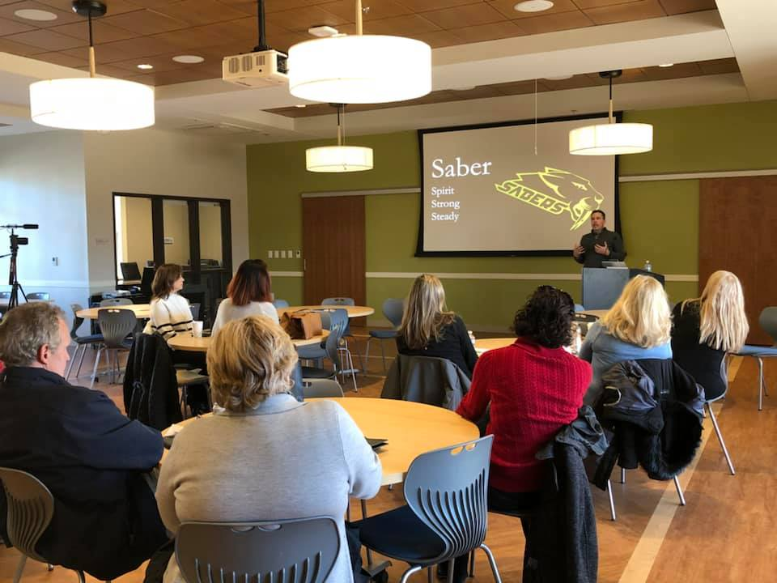
1. To what size group will the speech be delivered?
(50 to 100 people) The whole upper school, teachers, and family.
2. The speech will be delivered to a group made up of mostly?
(high school peers, families of the students, teachers and faculty)
3. Where will the event be held?
The event will take place in the commons where we eat lunch
(added a picture)
4. What kind of speech do you want?
(A combination of styles, that’s informative, story telling, and inspirational more than anything. To motivate the young classmen with a powerful speech I why I believe in resilience.)
5. Is there a key person(s) to whom the speech will be given? Tell us their name(s) and a little about his/her personality.
6. Please share information about events or memories you have together that you would like mentioned in the speech.
I would like to focus this area more on like high school and falling but being resilient and bouncing back into the grove of things. The name of my school is New community School and it’s a small dyslexic private school 6th grade to 12th grade. Playing sports and practice and all the crazy amount of stuff that just knocks you down in general at high school and how to be resilient to it.
7. What do you want your audience to think or feel as a result of experiencing your presentation?
practice and all I want the people in the audience to leave after all the speeches are done and have my as the only one in there mind on how they can be more resilient in there lives and bouncing back from whatever they have that hard in there life.
8. Is there an action that you would like your audience to take as a result of experiencing your presentation?
Take action in being more resilient in there day to day life
9. What is your deadline for delivering the speech?
April 19
10. Finally, please provide your speechwriter with any additional information you would like to have included in your speech. Include all information you feel is essential to your speech.

- The ideas on how I want to deliver resilience in my speech

Two quotes that describe the message I want to deliver
- “Do not judge me by my success, judge me by how many times I fell down and got back up again.” —Nelson Mandela, South African anti-apartheid revolutionary, political leader, and philanthropist
- “When we tackle obstacles, we find hidden reserves of courage and resilience we did not know we had. And it is only when we are faced with failure do we realise that these resources were always there within us. We only need to find them and move on with our lives,” —,A. P. J. Abdul Kalam scientist and 11th president of India
One of the amazing things about resilience is that many of us didn’t realize how resilient we were until we looked back at difficult times in our lives and saw the simple fact that we made it through, that we learned a thing or two, and that we had enough faith to keep going. So the next time you are in a tough spot in life — and believe me, these moments will come up whether we want them to or not — think back on a time that you did Persevere That right there is your resilience. It’s always accessible to you, and you have more of it than you know. (this is exactly how I want to show resilience in my speech but relate to hard times I faced with school and going to a dyslexic school and having dyslexia and how I was resilient through the process and relate dyslexia since all the other students have dyslexia.)
2. Converting my college app essay into speech and using those experiences
So I have my college application personal essay and it really shows experiences and moments that I was resilient and I’m going to paste it in this document and I really wanted to transition my college application essay into my speech with the same experiences and info but evolve all the information from the essay into the speech surrounding around the idea of resilience

College application essay:
I never imagined myself to be who I am today. As a child in kindergarten, I thought school was to have fun and learning would be easy. In first grade, we had to stand in front of the class and read. My day came, and my world changed, I could not read. I did not understand why everyone else could read so easily. I repeated the first grade and was asked to leave because they could not see a bright academic future for me. The message that I am not as good as my peers was deeply hurtful to me. I have not forgotten the emotional impact it had on me.

Following my diagnosis, my mother enrolled me in a school for dyslexic students. While my academic experiences improved due to better support and learning strategies my confidence remained low. Kids made fun of me, saying I went to a school for dummies. This greatly lowered my self-esteem. Luckily, I was athletic and started playing baseball in the second grade. Baseball boosted my confidence because it was easy for me. I quickly excelled at pitching. By eighth grade, I was pitching on the Varsity team. Alone on the mound, feeling as if you hold the game in your hand by a single pitch takes a lot of focus. Mentally, I could block out the mothers yelling, my coach and the anxiety. I focused on one thing, it was all up to me to pitch that strike. Off the field, I used this experience to block out other student’s criticism. I knew my brain was not wired the same as everyone else, but that did not mean I could not be successful. If I could focus on and achieve success as an athlete, why could I not give it my all and do it academically? I transferred to a larger school after the sixth grade, and my new school had better sports infrastructure. I still struggled with dyslexia, but now I had confidence and learning tools that I did not have in first grade. I took more time to study and do assignments but I developed a stronger resolve to face challenges life threw at me. I will always attribute this to sports, learning to block out the distractions, mentally focus and achieve my best at the current task. Strategic planning on the field and in the classroom.

Academics became more challenging in high school, and often I would feel the same helplessness I had felt as a child. I transferred to New Community School and decided to retake the sophomore year after consultation with my teachers. Even I was surprised by my academic performance, and New Community turned out to be a perfect place for me. I learned more advanced study strategies to prepare me for college. For the times I felt down and flashed back to first grade I could remind myself I can do this, and I AM doing this.

The biggest lesson of my life is that while we cannot choose our capabilities, we have the choice to work hard and persevere. I have learned to appreciate my own uniqueness as I volunteer with the Virginia Special Olympics, helping these children be the best they can be. They remind me we each hold a special talent and sometimes only tap the surface of what lies deep within. While I might not perform at the same academic level as my peers, it does not give reason to feel less or be less. Overcoming my own obstacles and helping others has helped me realize I can and will do this. Nothing can stop me from what I want to accomplish if I work hard, believe in myself and never give up. After all, what matters most is the progression and development of myself and who I’ve become, not the GPA that I feel stamped on my forehead.

