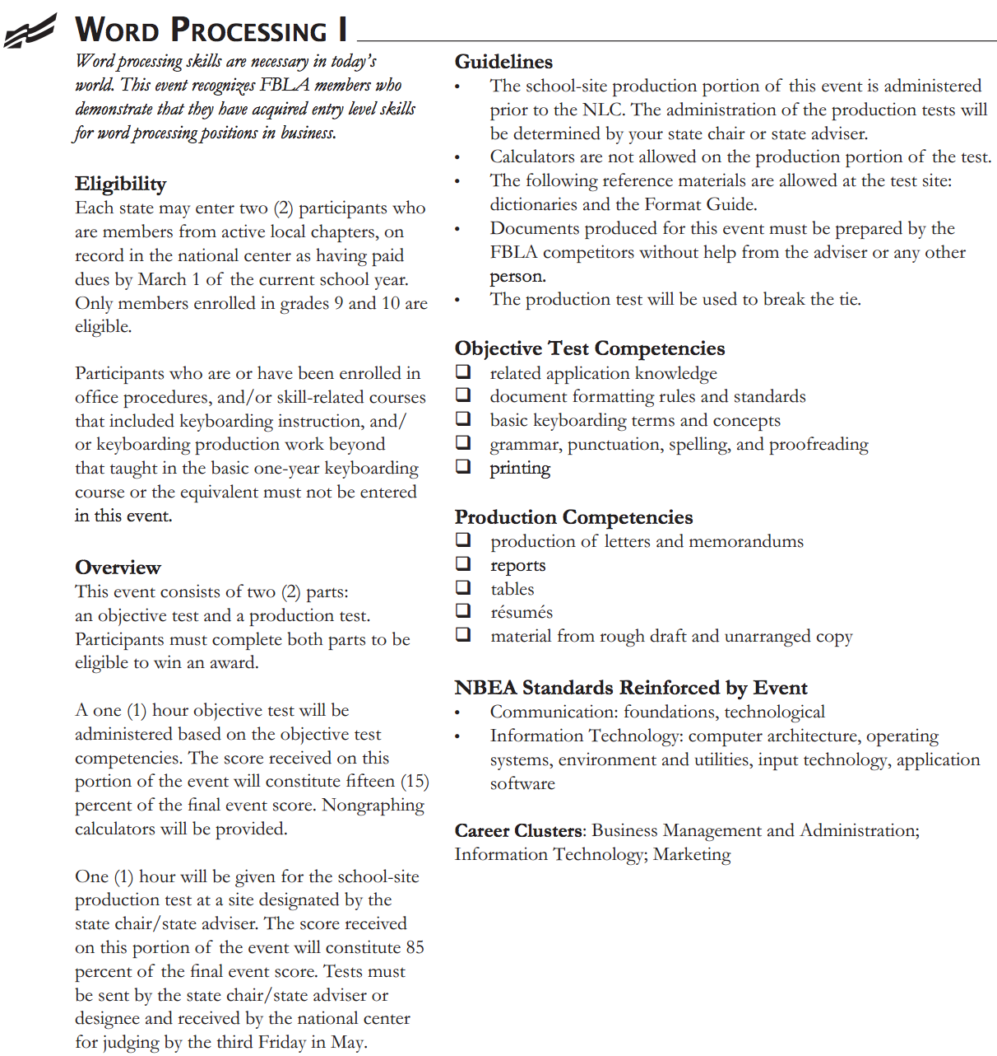

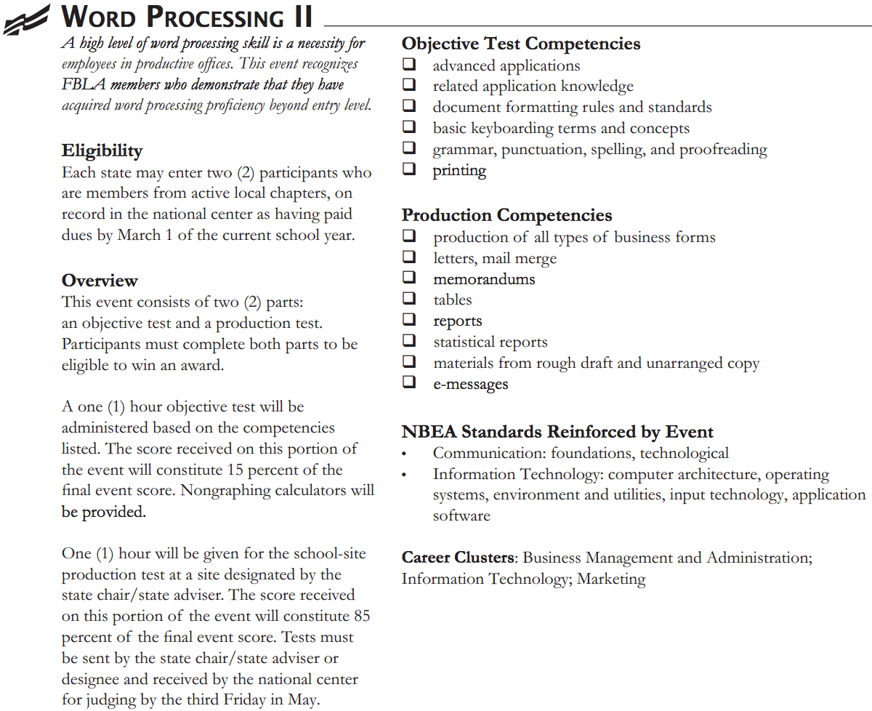

Objective Test = 100 Multiple-Choice Questions in 1 Hour

Production Test = Creating and Formatting About 10 Different Documents

Link to Real Production Test: <http://165.234.216.68/videos/NCATE/Business%20Ed/BIT%20391/FBLA%20Test%20Sample%201.pdf>

Link to FBLA Format Guide (used during production test): <http://www.fbla-pbl.org/docs/FBLA-PBLFormat%20Guide2010.pdf>

My Description and Analysis:

Word Processing requires a lot of preparation in order for one to do well. In regard to studying for the objective test, I printed out old exams that I had found online. Since last year was the first time that Word Processing I and Word Processing II were combined into one competition, I had to make sure to print out old tests from both events. This definitely helped me since the old exams gave me ideas about the topics that I should thoroughly review. In regard to studying for the production test, I familiarized myself with the FBLA Format Guide. Even though one can use the Format Guide while taking the production test, he or she should review it prior to taking the exam since each competitor only has one hour to complete multiple tasks. Another piece of advice for the production test is for competitors to be sure to proofread all of their work, if time is available. The production test counts for 85% of each competitor’s score, and, thus, one has to be sure to make as little mistakes as possible. Proofreading can make the difference between sitting on a chair and standing on the stage in front of 10,000 other FBLA members at the National Leadership Conference.