I will be speaking at the commemoration ceremony on the 70th anniversary of the liberation of the Concentration Camp Vaihingen/Enz. It will take place on the cemetery at the camp.

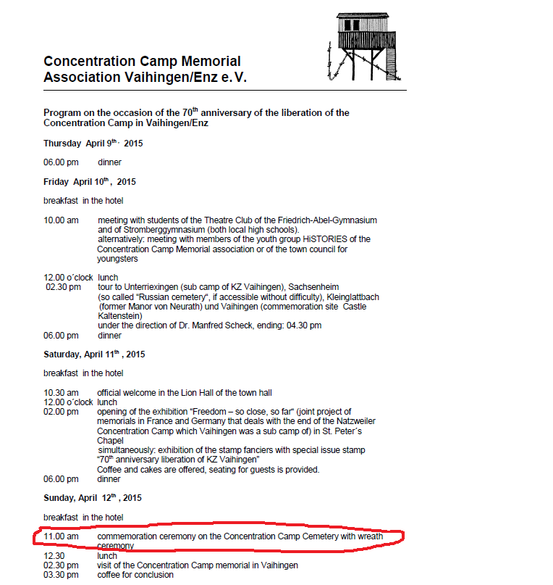

The memorial association have invited back the survivors who are still alive for this ceremony.

Here is a link to information and history on the camp itself

<http://www.gedenkstaette-vaihingen.de/3009-KZ-Gedenkstaette-Vaihingen-Enz.html?lang=1>

Under the association link there is a tab on survivors meeting in 2005:

<http://www.gedenkstaette-vaihingen.de/3026-Treffen-mit-Ueberlebenden-2005.html?lang=1>

This will be the 70th anniversary similar to the 60th anniversary that took place in 2005.

I will be accompanying my father who was a prisoner at the camp. He was from the Town of Radom/Poland. This is from the history on the web site:

On August 9th the transfer of 2189 concentration camp prisoners from Auschwitz to the construction project “Stoffel” took place. The prisoners exclusively were Polish Jews from the concentration camp Radom/Poland who had been evacuated on July 24th. They had been selected on the ramp of Auschwitz and classified as being able to work.

In the beginning of April the order was issued to evacuate the camp. Those being able to walk were sent to Dachau via train transport. In Dachau 515 men were listed.

(He was also one of the prisoners who was sent to Dachau just before the camp was liberated).

I need a special mention to Barroness Von Staden (who later became the wife of the West German Ambassador to the US - Berndt von Staden) - who was a 15 year old girl at the time. My father was one of the inmates who worked at her parent’s estate. He has told me stories of her families kindness to him and other prisoners. Her mother always talked to the prisoners and my father remembers how she would make sure he would be given an apple to eat and some milk to drink.

Stuff about the speech:

About 4-5 minutes.

There will probably be about 100 people there, mostly from the surrounding towns.

They probably all understand English, but it certainly is not their first language.

In addition to the son of one of the prisoners I am also currently President of the Radomer Mutual Cultural Center, an organization founded by people from Radom who survived the holocaust and came to the United States. The “second generation” have begun a transition of leadership from the survivors to the next generation.

Here is a speech that I gave at last year’s annual memorial service in New York. We try to have this service once a year to keep the memory alive. The audience in Vainaghan an der Enz is different but you may want to use some of the themes.

We are here to honor the memory of the Jews who perished during the Shoah. The six candles that we lit, symbolize the 6 million Jews whose lives were taken prematurely.

This is the 70th anniversary of the first liquidation of the Radom ghetto. World War 2 has been over for two generations. People say it is time to forget. Some say it is time to move on. Remembering the past is a waste of time. They say “What's the point, why care?” Let the world get back to normal.

What a mistake forgetting would be. Everyday we hear about new anti-Semitic acts that are taking place. We can’t forget what happened, we must remember. Remembering does not change history. Remembering changes the future.

Remembering becomes more important as the years go by. As we stand here today, we are closer to the moment when the Holocaust will cease to be a living memory. It will become history. Future generations will not be able to hear the truth directly from those who lived through it.

I have been going to Radomer functions with my family for a long time. I am amazed as to how the survivors, who came here with nothing and who suffered through horrors that no one could imagine were able to keep this group going. I remember the Radomer society as one whose members wanted to do things to celebrate living while still remembering their lost loved ones. I remember both the liberation balls and the memorial services. It was a very delicate balance and I believe the second generation and the generations to follow benefitted from these endeavors.

My generation and our children have been inspired by you. All of you survivors have shown us how to live and also how to remember. My generation has had the privilege of knowing you. We have also been inspired by the dedication of Radomer past leaders. Leaders like Jack Werber *(Millie),* Henry Hanover *(Paula),* and Sam Feldman *(Celia),* while no longer with us, will be remembered for their dedication and devotion to the society. I want to assure all of you that together with others of the second and third generations we will continue what these leaders kept alive. It is our obligation to make sure that precious memories continue and are not forgotten. It is our duty to share your stories, honor your legacy, and preserve the memory for our children, our grandchildren, and for the future of mankind.

On this day when we remember those who perished, may we recall not only terror of their deaths, but also the splendor of their lives! May their memory inspire us to live meaningful lives and help ensure that part of who they were shall live forever.

Topics that we might want to include:

One of my co-workers asked me why do you want to go to Germany? Do you really want to support a place that did that to your parents and murdered 6 million Jews?

My current thoughts on an answer:

While I will never forget (and I will teach my children never to forget). My parent’s lives in the United States have taught me to learn from what happened but move on and try to live life to the fullest. I see a town that is trying to keep the memory of what happened alive and I want to thank the association for all their efforts.

My father wanted to go back and I certainly was going to go with him.